**CMPE 283**

**Virtualization**

**Assignment 1:**

Create an instance with nested virtualization using the script generated by **“Equivalent Command Line”**. Configuration of an instance has been set in this way.

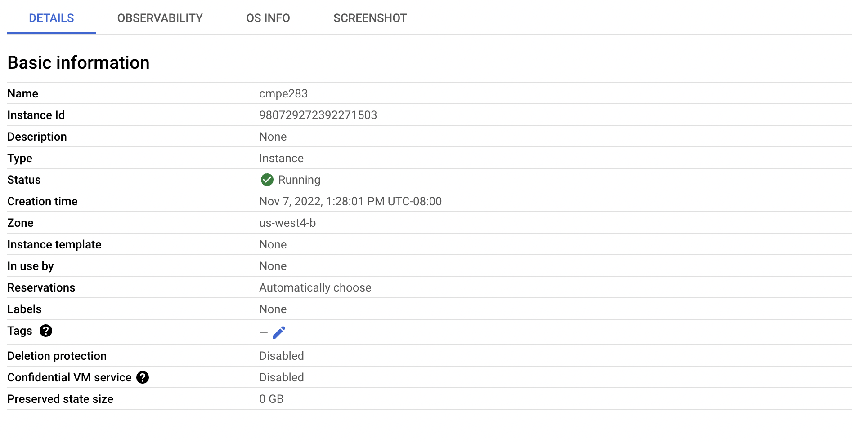

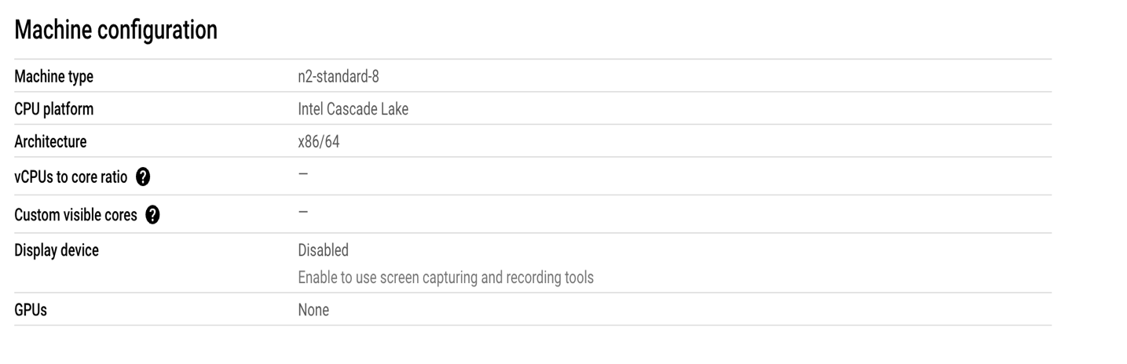

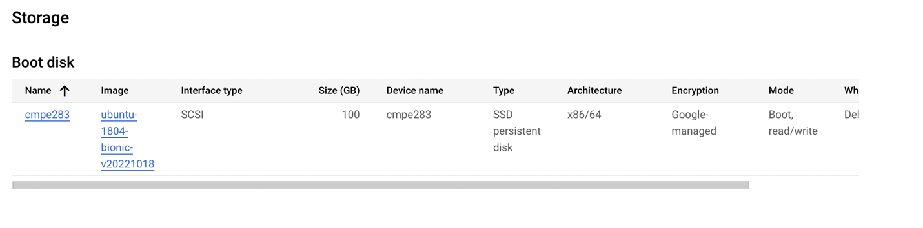

SSH into the instance using **SSH** option under connect.

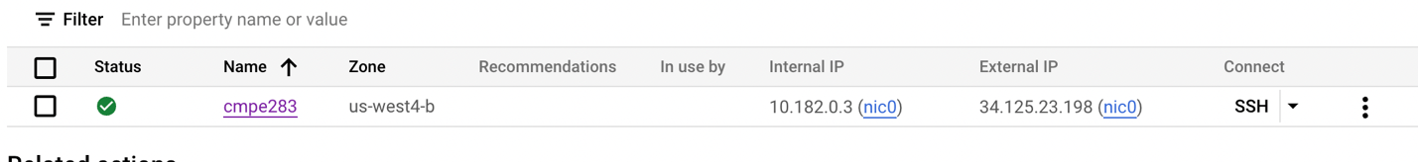

After getting into an instance, create a directory using below command.

* mkdir cmpe283

Create .c and make files in the directory.

* .c consisting of the kernel module code.
* Make file is used to compile the .c file.



Once the files are created, install the required libraries using below command.

* sudo apt-get update

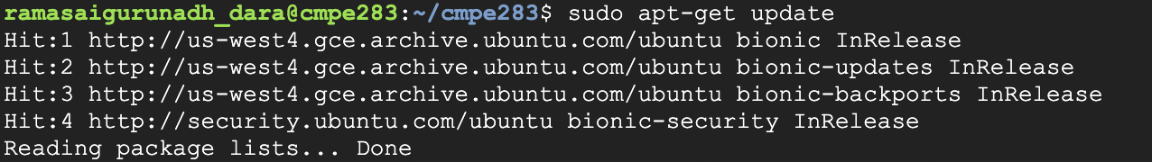

* sudo apt-get upgrade

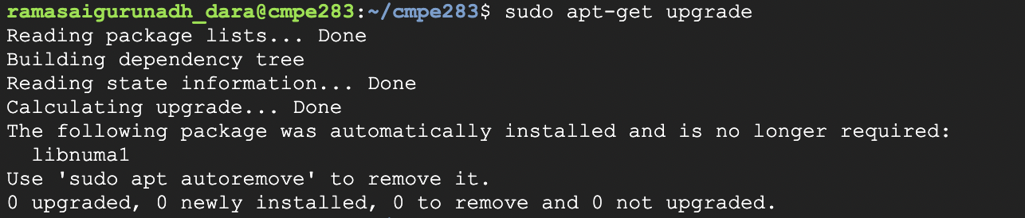

* sudo apt-get install vim gcc make linux-headers-$(uname -r)

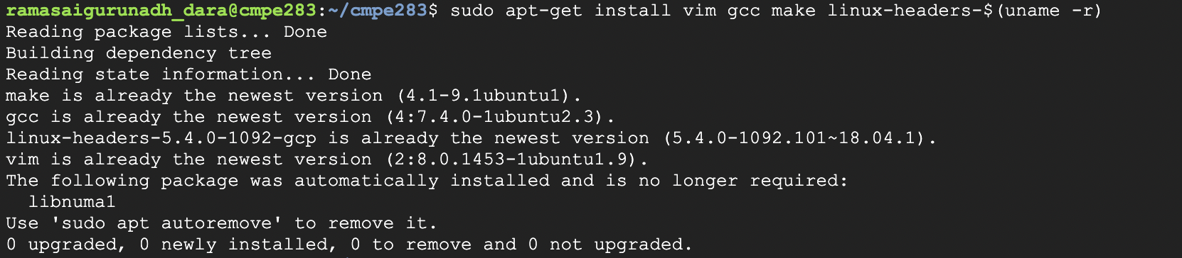

* Run **“make”** command to initiate the compilation.

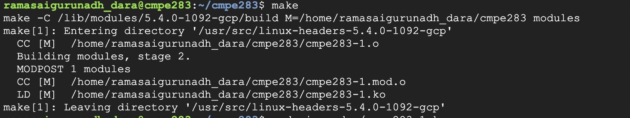

* Run the code using the command “ sudo dmesg”

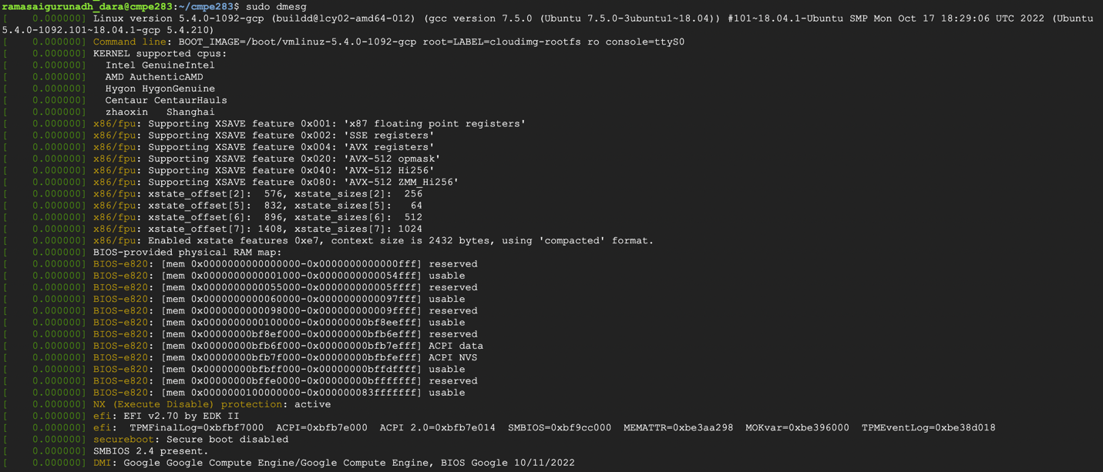

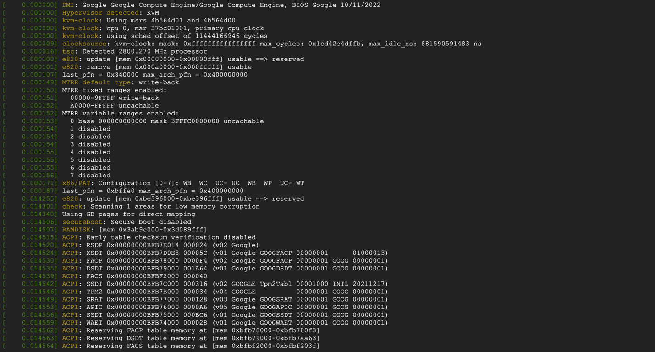

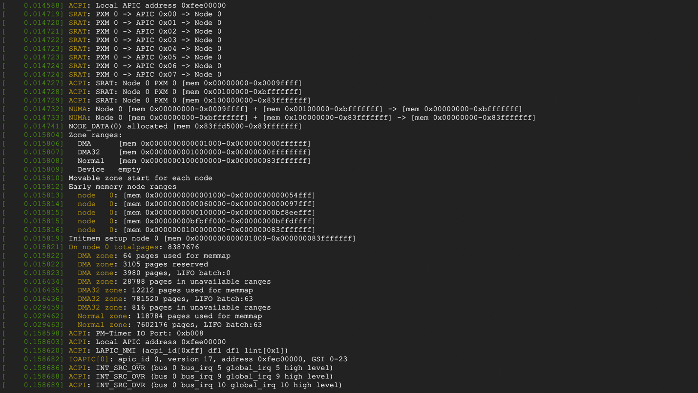

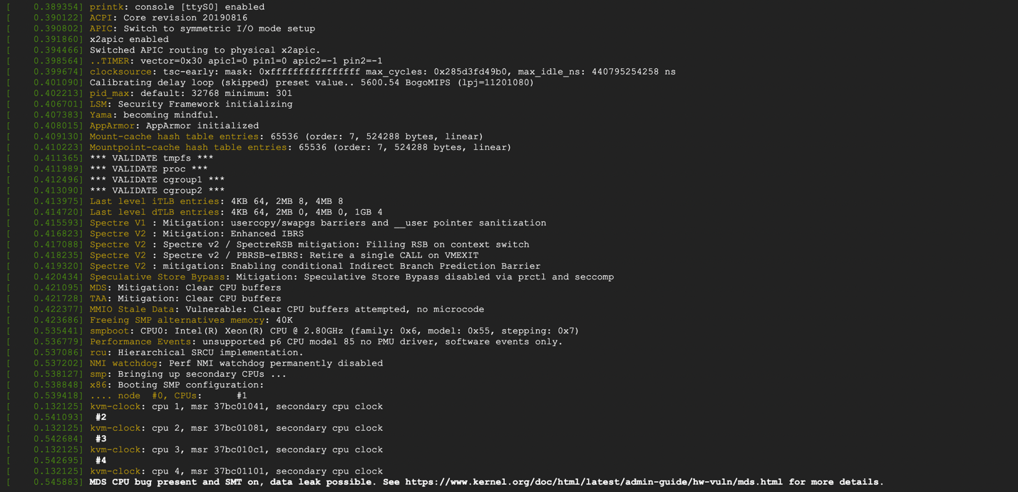

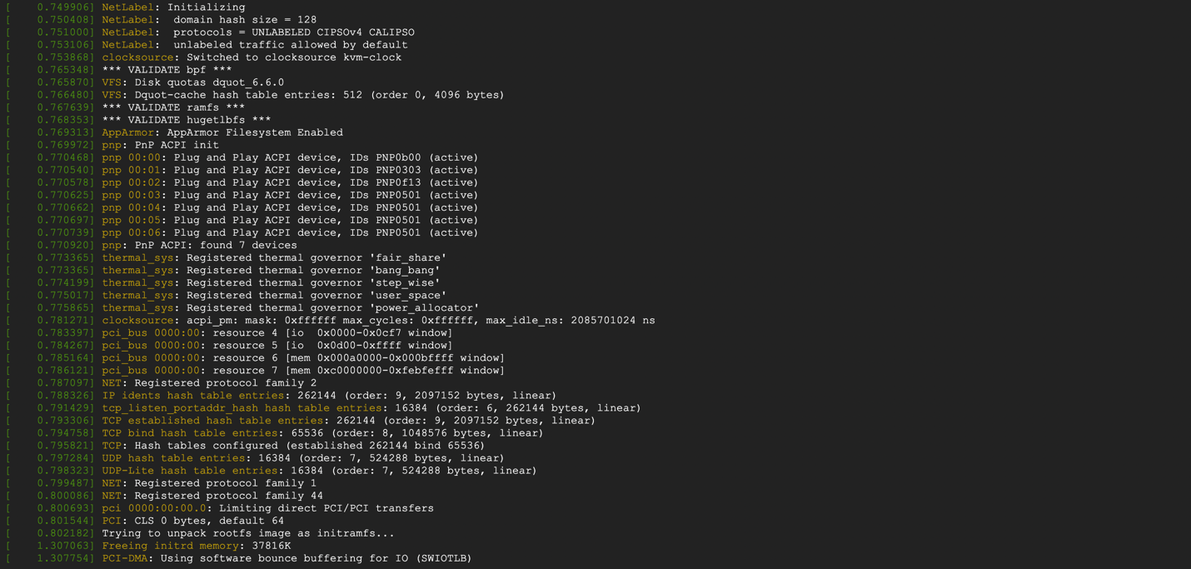

Output:

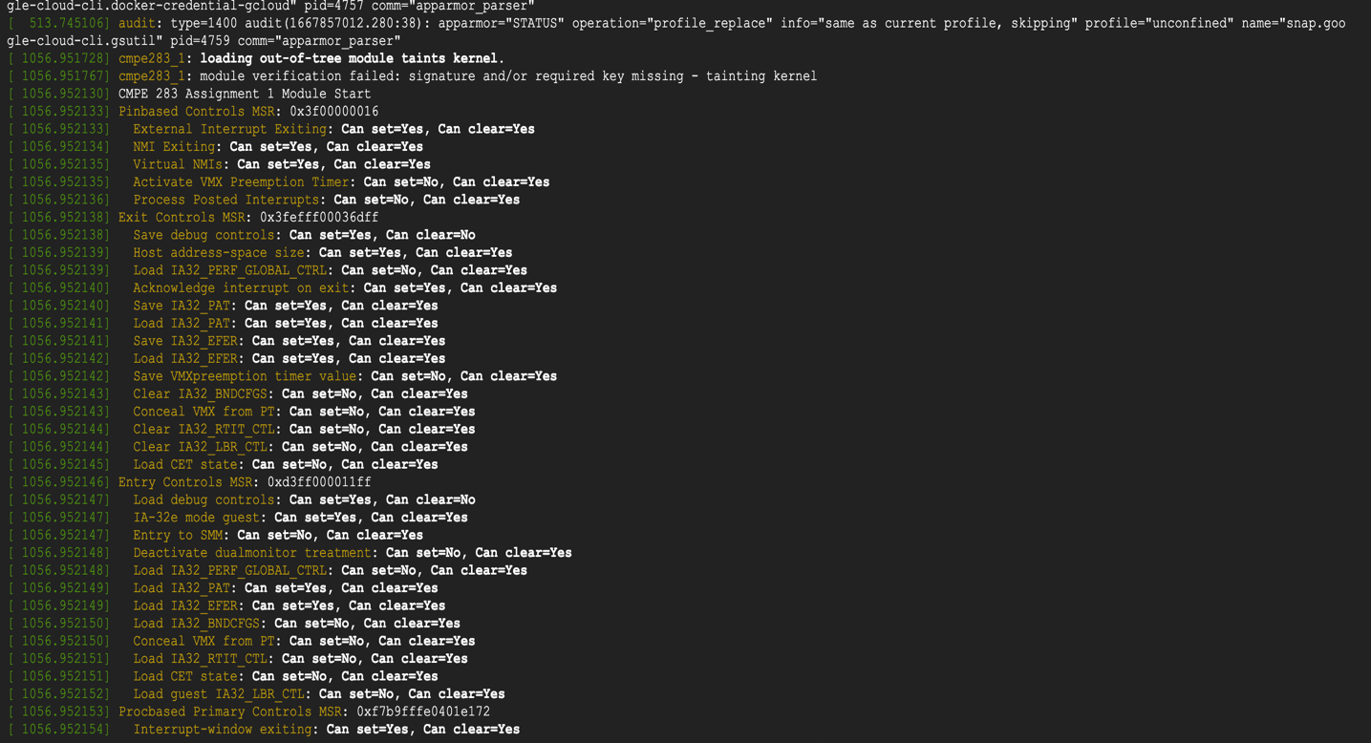

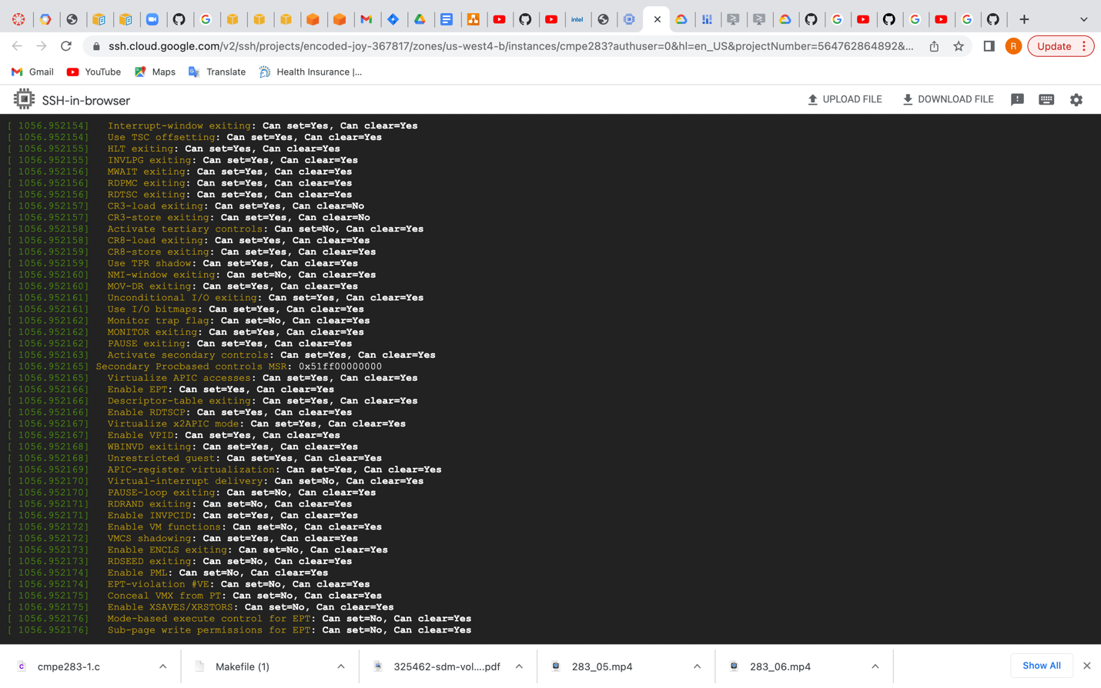



Once the code is run it generates the .ko, .mod, .mod.o, .o, modules.order, Module.symvers files.

